|  |  |  |
| --- | --- | --- |
|  | ***AI in Sustainable Energy and Environment***  *Journal homepage:* [*aisesjournal.com*](https://aisesjournal.com/) | ***Online*** |

A Smart Demand Response and EV Routing Framework for Managing Peak Demand and Distribution Network Congestion

Mohan.S1*, C.Nayanatara 2, Rajkumar.K3,

*1. Department of Electrical and Electronics Engineering Sri Sairam Engineering College Chennai- -600044 ,India*

*2. . Department of Electrical and Electronics Engineering Sri Sairam Engineering College Chennai- -600044 ,India*

*3. Department of Electrical and Electronics Engineering Sri Sairam Engineering College Chennai- -600044 ,India*

**Abstract**   
The growing demand for electricity, coupled with challenges such as peak load and network congestion, has necessitated the development of effective energy management strategies. This study presents an optimized framework that leverages demand response (DR) programs alongside electric vehicle (EV) routing to alleviate stress on distribution networks. The proposed approach emphasizes both participating and non-participating consumers to ensure equitable benefits across the network. By integrating EV routing within the DR scheme, the study addresses dynamic load distribution, especially during critical peak periods. To validate the proposed approach, simulation studies were performed on the IEEE 33-bus distribution network under both normal and increased loading scenarios. An incremental learning-based model was employed to iteratively enhance the system's adaptability and performance. Results demonstrate that the coordinated application of DR programs and EV routing significantly reduces peak demand and improves congestion management, thereby contributing to a more resilient and efficient power distribution system.

**Keywords—** Congestion management, Incremental learning, Peak load reduction, Demand response, Electric vehicle routing

**1. Introduction**

The evolving landscape of energy consumption and distribution systems presents pressing challenges, particularly in addressing peak demand periods and managing congestion within power networks [1]. As electricity usage continues to rise, especially during high-demand intervals, traditional grid infrastructure often struggles to maintain stability and efficiency. In response, various intelligent energy management strategies have been proposed, among which Demand Response Programs (DRPs) have gained prominence. Recently, the integration of Electric Vehicle (EV) routing within DR frameworks has been recognized as a valuable approach for balancing energy distribution and enhancing system resilience [18]. This research presents a comprehensive study of the coordinated application of DRPs and EV routing to manage congestion and improve consumer welfare. The core objective is to optimize energy usage by leveraging consumer participation in DRPs while considering the systemic impact on both engaged and non-engaged consumers [19]. By examining participation behaviour and its implications, the study seeks to ensure equitable distribution of benefits across the entire consumer base. A fundamental research question addressed herein is how the combined deployment of DRPs and EV routing can be strategically utilized to reduce peak load and alleviate congestion, thereby supporting a more reliable and consumer-responsive power distribution network. To explore this, a series of simulations were carried out on the IEEE 33-bus distribution system under both normal and elevated (double) loading conditions [1].

The study employs an incremental learning-based modelling approach to capture the dynamic nature of energy consumption and adaptively improve the performance of the proposed system. This methodology enables continuous refinement of control strategies in response to changing load profiles and consumer behaviour. The results derived from the simulations provide strong evidence supporting the potential of integrated DRPs and EV routing to significantly mitigate peak demand and enhance congestion management capabilities within the distribution network [2].

**2. Demand Response Program Modelling**

Demand Response Programs (DRPs) serve as a strategic tool to reshape consumer demand patterns, aligning them more effectively with the available generation capacity, particularly from intermittent renewable energy sources. By strategically shifting or reducing loads, DRPs help to flatten the load curve and relieve stress on the power grid during periods of high demand [11]. This contributes to enhanced grid reliability and operational efficiency. Moreover, DRPs empower consumers to actively participate in system-level load management by voluntarily curbing their electricity usage during peak hours or under conditions of limited generation. Such participatory load control mechanisms play a crucial role in balancing supply and demand, especially in scenarios involving generation shortfalls or emergency conditions.

A critical component of this modeling approach is the strategic formulation of tariff schemes aimed at motivating consumer engagement. Well-designed pricing models play a vital role in enhancing power system efficiency by promoting energy consumption during low-demand periods and reducing usage during peak hours. In this research, the Demand Response Program (DRP) is formulated by examining the structural attributes of the distribution network alongside the functional potential of the demand response strategy.Load profile leveling is achieved by incorporating scheduled demand shifts and curtailments based on the DR potential of the consumers, thereby contributing to a more balanced and responsive energy distribution system.

The objective of the Demand Response Program (DRP) is to minimize the deviation of instantaneous active load from its average value, thereby flattening the load curve. The optimization problem is formulated as follows:

|  |  |
| --- | --- |
|  | (1) |
|  | (2) |
|  | (3) |
|  | (4) |

Where are :

*PLA*t -Active load at time t

*PLAav*g-Average active load across the scheduling horizon

*PNRt-*non-responsive load at time t

*PLRt*--Responsive load at time t

*PIt*– Incentive-based load at time t

*TLlt​*– Total load at bus *l* at time t

*LP* – Maximum permissible load participation ratio

-total load shifted from time t to time *t*-1

Based on the classification of customer demand into active responsive and non-responsive components, a tailored Demand Response Program (DRP) is formulated. Each bus in the distribution system may serve a diverse mix of load types, including commercial, residential, and industrial consumers. The DRP strategically modifies the consumption behavior of responsive loads by encouraging a shift from high-demand (peak) periods to lower-demand (off-peak) intervals. This load shifting contributes to overall demand flattening and enhances grid stability After deploying the Demand Response Program (DRP), a power flow study is performed to analyze its influence on the operational behavior of the system under the modified load scenarios.

**3. EV ROUTING MODELLING**

Integrating electric vehicle routing within distributed power system networks offers a strategic pathway toward sustainable transportation and efficient energy distribution. By leveraging renewable energy sources, enhancing grid performance, and promoting optimal charging strategies, this approach contributes to a more eco-friendly and dependable energy ecosystem [2].The objective function aims to minimize the overall cost, which includes costs associated with power consumption, battery degradation, and current flow losses in the distribution system, considering different time slots, buses, and scenarios.

|  |  |
| --- | --- |
|  | (5) |

Where are:

-Active power price at time slot t

- Reactive power price at time slot t

-Aggregated active power of electric vehicles at time t, bus i, and scenario s

-Aggregated reactive power of electric vehicles at time t, bus i, and scenario s

Battery degradation cost of electric vehicles at time t, bus i, and scenario s

1. **OBJECTIVE FUNCTION**

The quadratic equation presented in the following formula aims to maximize customer welfare through the objective function. (6)

|  |  |
| --- | --- |
|  | (6) |

Where are:

Pdi - real power demand

adi,bdi,cdi- demand cost co-efficient

D -Demand,

M -Total number of buses .

Consequently, the objective function is applicable to all buses equipped with Distributed Generation (DG) units, considering their respective loading capacities denoted by β, as illustrated in Equation (7)

|  |  |
| --- | --- |
|  | (7) |

1. **Constraints**

The primary goal of the optimization framework is to identify the optimal locations for Distributed Generation (DG) units within the distribution network based on predefined performance criteria. This process aims to enhance system efficiency, reliability, or economic operation depending on the chosen objective.

**Equality Constraints**

The equality constraints are derived from the core power flow equations that define the steady-state behavior of the electrical system. These constraints maintain the balance between power generation, consumption, and transmission at each bus and line, adhering to the physical principles governing the network.

|  |  |
| --- | --- |
|  | (8) |

**Inequality Constraints:**

Generation limits:

The actual power generation constraints for each generator linked to the bus 'm' are restricted

|  |  |
| --- | --- |
|  | (9) |

The line flow constraints for buses i and m are mentioned below

|  |  |
| --- | --- |
|  | (10)  (11) |

The Bus voltage limits are mentioned as

|  |  |
| --- | --- |
|  | (12) |

The scheduling of an ideal Demand Response Program (DRP) aims to minimize generation costs, reduce power loss, and achieve the greatest reduction in peak load.

1. **SIMULATION RESULTS AND DISCUSSIONS**

The Voltage Deviation Index (VDI) serves as a quantitative indicator of voltage stability within a power distribution system. It measures the extent to which actual bus voltages deviate from their nominal values, either expressed as a numerical value or percentage. This index is essential for evaluating the performance, quality, and reliability of power delivery to end users.VDI plays a critical role in distribution system analysis, as excessive deviations can adversely affect the operation of sensitive electrical equipment and compromise consumer satisfaction. Common voltage anomalies such as sags, swells, and interruptions are captured through this index, making it a key parameter for power quality assessment. A VDI value of **1.0** typically signifies a system operating under ideal voltage conditions with minimal deviation across all nodes. This research examines how the application of a Demand Response Program (DRP) influences voltage regulation within the distribution network. The results, as presented in **Table 1**, indicate that the application of DRP strategies leads to significant improvement in voltage stability, with the VDI reaching a value of unity post-implementation—demonstrating enhanced load balancing and reduced stress on the network.

Table1.Bus Voltage levelwith DRP IEEE 33 bus system

|  |  |
| --- | --- |
| **Voltage level**  **(p.u)** | **With DRP** |
| 0.45-0.64 | - |
| 0.65-0.73 | - |
| 0.74-0.85 | - |
| 0.86-0.96 | - |
| 0.97-1.01 | 27  (3,4,5,7,8,9,10,12,13,14,15,16,17,18,20,21,22,23,24,  25,26,27,29,30,31,32,33) |
| 1.02-1.2 | 5  (2,6,11,19,28) |

**Power Loss Analysis Under Varying Load Conditions:** An important performance indicator in power distribution networks is the total real power loss incurred under different loading scenarios. In this study, power losses were evaluated across three distinct operational conditions: peak load, moderate load, and low load. These scenarios represent typical variations in demand experienced by distribution systems throughout the day. The deployment of the Demand Response Program (DRP) resulted in a significant decrease in power losses under varying load scenarios. This enhancement is primarily due to improved load balancing and the effective mitigation of peak demand which collectively minimize stress on the network infrastructure. The corresponding results are presented in Table.2, clearly highlighting the effectiveness of DRP in reducing losses and enhancing the overall efficiency of the system under varying load conditions.

Table.2Power loss comparison under different load conditions IEEE 33 bus system

|  |  |  |
| --- | --- | --- |
| **Load type** | **Bus Location** | **Power loss With**  **DRP**  **(%)** |
| Peak Load | 7 | 32.19 |
| Moderate Load | 22 | 22.43 |
| Low Load | 19 | 16.56 |

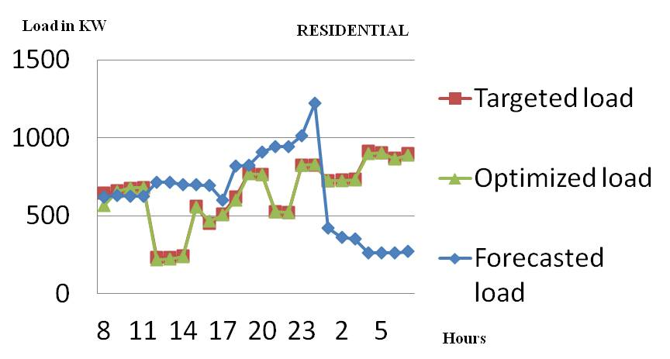

Figure.1 Demand response program for residential consumers

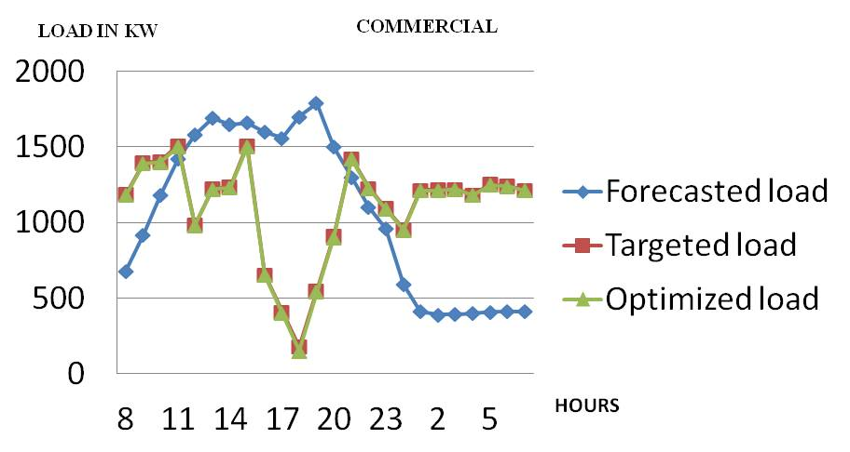

Figure.2 Demand response program for commercial consumers

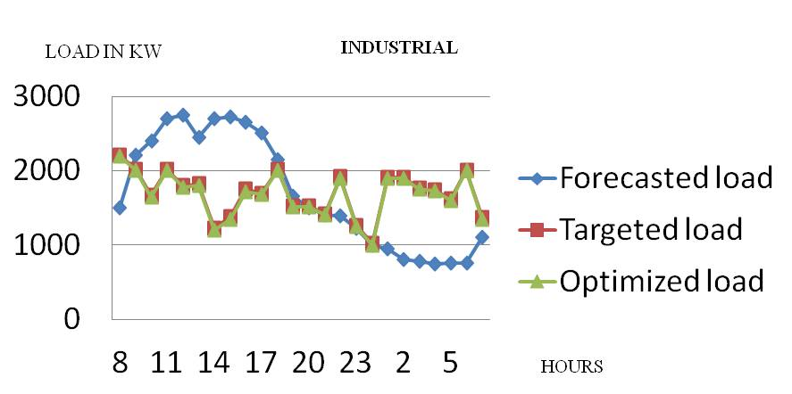

Figure.2 Demand response program for industrial consumers

The Demand Response Program (DRP) was implemented for commercial, residential, and industrial consumer segments to evaluate its effectiveness in managing electricity demand. Load demand, expressed in kilowatts (kW), was monitored over time to capture variations in consumption patterns across a typical operating period.The simulation results indicate a substantial reduction in peak demand following the application of DR strategies. This outcome confirms the DRP’s effectiveness in flattening load curves by shifting or curtailing consumption during critical periods, thereby contributing to enhanced operational efficiency and system stability.

**Optimization of Discrete Device for Power loss maximization:** The output results in the table 6.3 clearly shows that power loss reduction maximum during the peak load conditions and it is clearly known that power loss at maximum occurs at during type 2 distributed generation and location is at 8.

Table3. Power loss reduction at peak load conditions IEEE 33 bus system

|  |  |  |  |
| --- | --- | --- | --- |
| **Line** | **Device** | **DG size (MW)** | **PLR**  **(%)** |
| 5 | 3 | 2.03 | 3.76 |
| 3 | 2 | 2.62 | 7.38 |
| 8 | 2 | 1.56 | 24.59 |
| 7 | 1 | 2.58 | 14.04 |
| 9 | 3 | 1.22 | 17.48 |
| 10 | 3 | 1.04 | 7.99 |
| 12 | 2 | 2.43 | 12.63 |

1. **Conculsion**

The Electric Vehicle (EV) routing model and the associated objective function are developed to simultaneously address both spatial and temporal dimensions of optimization. The proposed objective function is designed to simultaneously enhance the profitability for electric vehicle (EV) users and reduce power loss-related expenses for the Distribution Network Operator (DNO), effectively aligning the goals of both consumers and the power grid. The Demand Response Program (DRP) scheduling is applied across multiple load levels to assess its operational impact. Initial evaluations are performed using the standard IEEE 33-bus distribution test system. Critical buses within the network are identified based on load sensitivity and voltage deviations, enabling the determination of optimal control settings for distributed generation (DG) units. The simulation results confirm that the coordinated implementation of DRP strategies and DG control contributes significantly to performance enhancement. Key improvements include effective peak load reduction, improved voltage profiles, and minimized power losses. These findings underscore the potential of demand-side interventions in improving distribution system reliability and operational efficiency.

1. **References**
2. Sharmila, P., Mahadevan, S.,Baskaran, J.,Nayanatara,C "Heuristic DRP-DGoptimization strategy adopted for maximizing total social welfare in the real time Indian utility network". IET Renew. Power Gener. 16, 3092–3107 (2022).https://doi.org/10.1049/rpg2.12560
3. Saleh Aghajan-Eshkevari, Mohammad Taghi Ameli, Sasan Azad,, Optimal routing and power management of electric vehicles in coupled power distribution and transportation systemsApplied Energy,Volume 341,2023,121126,ISSN 0306-2619,

https://doi.org/10.1016/j.apenergy.2023.121126.

1. Benvindo R. Pereira Jr., Geraldo R. Martins da Costa, Javier Contreras, and José R. Sanches Mantovani,, “ Optimal Distributed Generation and Reactive Power Allocation in Electrical Distribution Systems” IEEE transactions on sustainable energy, vol. 7, no. 3,July 2016.
2. C.Wang and M.H.Nehrir, „Analytical approaches for optimal placement of distributed generation sources in power systems‟, IEEE Transactions on Power Systems, (2004),19, (.4), pp.2068-2076.
3. B.B.Alagoz, A.Kaygusuz,”Dynamic energy pricing by closed loop fractional- order PI control system and energy balancing in smart grid energy markets”, Transactions of the Institute of measurement and control,(2016),38,[5], pp.565-578.
4. Y. Yorozu, M. Hirano, K. Oka, and Y. Tagawa, “Electron spectroscopy studies on magneto-optical media and plastic substrate interface,” IEEE Transl. J. Magn. Japan, vol. 2, pp. 740–741, August 1987 [Digests 9th Annual Conf. Magnetics Japan, p. 301, 1982].
5. H. Xing, H. Cheng, Y. Zhang, P. Zeng, "Active distribution network expansion planning integrating dispersed energy storage systems", IET Generation, Transmission and Distribution, (2016),10, (3), pp. 638-644.
6. H.Zareipour, K.Bhattacharya and C.A, Canizares, „Distributed generation: current status and challenges‟,IEEE Proceedings of NAPS,(2004).
7. A. M. Eltamaly and M. A. Mohamed,Optimal sizing and designing of hybrid renewable energy systems in smart grid applications, in Advances in Renewable Energies and Power Technologies. Amsterdam, The Netherlands: Elsevier, 2018, pp. 231–313.
8. Nayanatara, C, Baskaran, J & Kothari, DP, Hybrid Optimization implemented for DistributedGeneration Parameters in a power System network‟, International Journal of Electric Power and Energy systems,(2016), Elsevier, 78,pp. 690-699.
9. Nayanatara, C, Baskaran, J & Kothari, DP,„Approach of hybrid PBIL control in distributed Generation parameters for IEEE and real time Indian utility system‟, IET Renewable Power Generation,(2016): vol. 1752, pp. 1416.
10. Nayanatara, C, Baskaran, J & Kothari, DP,GA Implemented for Distribution Generation Parameters in IEEE and Indian Utility System‟,MiddleEastJournalofScientificResearch,(2015),23,(6),pp.1127-1136.
11. C.Yammani, Sydulu Maheswarapu, sailajakumari, „Optimal placement of Multi DGs in distribution system with considering the DG bus available limits‟Energy and Power,(2013),18,(1),pp.18-23
12. A.A. Chowdhury, S.K. Agarwal, and D.O. Koval, „Reliability modeling of Distributed Generation in Conventional Distribution Systems Planning and Analysis‟, IEEE Transactions on Industry Applications,(2003), 39, (5), pp. 1493-1498.
13. R.K.Singh and S.K.Goswami, „Optimum allocation of Distributed Generations based on Nodal pricing for profit, loss reduction and voltage improvement including voltage rise issue‟,International Journal of Electric Power and Energy systems,(2010),32,(6),pp.637-644.
14. T.Ackermann, G.Andersson and L.Soder, ‟Distributed generation: A definition‟, Electric Power System Research,(2001),57,(3),pp.195- 204
15. W.E.Khattam, K.Bhattacharya, Y.Hegazy, M.M.A.Salama,’ Optimal investment planning for distributed generation in a competitive Electricity market’, IEEE Transactions on Power System, (2014), 19, (4), pp.206-212
16. Mohan.S, C. Nayanatara and J. Baskaran, "Distributed Network Welfare Maximization DSM-DG Strategy," 2022 International Conference on Power, Energy, Control and Transmission Systems (ICPECTS), Chennai, India, 2022, pp. 1-4, doi: 10.1109/ICPECTS56089.2022.10047639.
17. G. V. Swaminathan, S. Periasamy and S. Padmanaban, "Inertia Emulation in Autonomous DC Microgrids by Attenuation and Low Pass Filtering of Capacitor Current," 2022 IEEE 2nd International Conference on Sustainable Energy and Future Electric Transportation (SeFeT), Hyderabad, India, 2022, pp. 1-6, doi: 10.1109/SeFeT55524.2022.9909216.