|  |  |  |
| --- | --- | --- |
|  | ***AI in Sustainable Energy and Environment***  *Journal homepage:* [*aisesjournal.com*](https://aisesjournal.com/) | ***Online*** |

**AI-Integrated and Energy-Optimized Robotic Systems for Autonomous Water Surface Purification: A Comprehensive Survey**

**a**Ganpisetti Dhanya Sri, **a**Karri Gowtham Venkata Reddy, **a**P Venkata Sai Chandrakanth, **a**V Viswanath Shenoi,

**a**S Shanmugan

**a**Integrated Research and discovery, department, Koneru Lakshmaiah Education Foundation, green field, vadesmaram, guntur 522502, Andhra Pradesh, India.

Emails: (Sri) [2300032840@kluniversity.in](mailto:2300032840@kluniversity.in), (Karri) [2300032792@kluniversity.in](mailto:2300032792@kluniversity.in),

(sai) [venkatasaichandrakanth@kluniversity.in](mailto:venkatasaichandrakanth@kluniversity.in),(shenoi) [viswanathcse@kluniversity.in](mailto:viswanathcse@kluniversity.in),

(shanmugan) [shanmugan@kluniversity.in](mailto:shanmugan@kluniversity.in)

Corresponding author: [2300032840@kluniversity.in](mailto:2300032840@kluniversity.in) and [2300032792@kluniversity.in](mailto:2300032792@kluniversity.in)

**Abstract:**

This paper explores the role of industrial and water surface cleaning robots in enhancing efficiency, safety, and sustainability across various sectors. Industrial robots, including articulated, SCARA, Delta, Cartesian, and collaborative robots (Cobots), are transforming manufacturing processes with their ability to perform precise, repetitive, and complex tasks such as welding, assembly, and quality inspection. In parallel, cleaning robots are designed for diverse applications, from floor and window cleaning to specialized water surface cleaning, utilizing advanced navigation and obstacle avoidance techniques. The study emphasizes the importance of robotics technology in managing critical tasks like waste collection on water surfaces, which mitigates environmental hazards caused by pollution and supports ecosystem health. Additionally, advancements in AI and machine learning are enabling these robots to work more efficiently alongside humans, while Robots as a Service (RaaS) offers cost-effective solutions for small and medium enterprises. Through the integration of robotics, industries are not only optimizing operational performance but also contributing to sustainable practices. The findings underscore the potential for further development in robotics to address environmental challenges, especially in water quality management and waste reduction.

**Keywords:** robots, robotics, cleaning, water surface, machine learning, water pollution

# **Introduction**

Water is essential for life and plays a major role in our daily life and human body needs the certain amount of water to live and the basic uses for human. Here are some reasons of highlighting its importance:

Hydration, Temperature Regulation, Skin Health, Agriculture and farming, Sanitation and Cooking and food Preparation and cleaning.

Water pollution is the contamination of water bodies such as rivers, lakes, and oceans with harmful substances making them incapable of being used. It hurts aquatic lives, breaks up ecosystems, and causes health issues in humans. Common pollutants include chemicals, industrial waste, plastics, and sewage. Water pollution often leads to waterborne diseases, loss of biodiversity, and scarcity of clean water. Human activities include improper waste disposal, deforestation, and overuse of pesticides.

Water pollution is caused by a variety of factors, including:

1. Industrial Discharges

Industrial discharges are a major contributor to water pollution, these discharges come from a wide range of industries, mining and power generation and often heavy metals, and other pollutants.

2. Plastic Waste

Plastic waste is one of the most harmful in water pollution. This occurs in the river, lakes and oceans

3. Oil Spills

Oil is one of the worst pollutants in water bodies. Oil spillage caused by ruptured pipelines, Illegal Discharge and oil tankers are some of the most disastrous effects on water bodies.

4. Agricultural runoff

Agricultural operations is one of the major contributors of nutrient water pollution. When it rains the fertilizers used on crops can end up in the rivers and lakes. Nitrogen and phosphorus in factitious fertilizers enhance algal bloom; eutrophication reduces water oxygen levels and kills aquatic life.

When rivers become polluted, several adverse effects occur:

Pollutants affect rivers, oceans, and lakes in several ways that are destructive to ecosystems, humans and economies.

Here are some of the major consequences of water pollution:

1.Ecosystem Damage

Damage done to ecosystems as an effect of water pollution is alarming and highly deadly to the quality and survival of ecosystems in the environment. Ways through which water pollution leads to harming the ecosystem include

1. Loss of Biodiversity

2. Disruption of the Food Chain

2. Human Health Risks

pollution of water poses severe health effects on the life of man, when polluting in the river, the lakes through the oil factory as well as various industries, different health effects occur they include cancer, antibiotic resistance, skin and gastrointestinal complications, reduced access to safe water, developmental issues and hormonal imbalances.

Hear is the solution to clean the water

1. Physical Filtration

2. Chemical Treatment

3. Robotic Cleaners

4. Magnetic Nanotechnology

5. Reduce the number of chemicals you use

6. Clean Water Campaigner

There are many forms of solutions to clean water. we preferred to clean the water with robot.

What is robot:

A robot is an artifact designed for the purpose of acting autonomously or with minimal human intervention as possible. They act and convey their surroundings using sensors, software and mechanical components.

Different applications of robot:

Robotics are basically bifurcated into industrial robots which are used in manufacturing something and service robots as in cleaning or healthcare or Personal/Home use. Each one is unique in that it gives a particular kind of performance for specific tasks, ranging from mechanized repetitive functions in factories to supplementary aid to humans in their daily endeavors.[4]

High-tech systems like personal robots are viewed as becoming an everyday human product similar to personal devices. Among these types of robots, practical application ones as well as those for scientific purposes will be developed for the purpose of multimodal communication as well as human-like interactions.

Many people lose their lives due to diseases associated with safe water, and plastics have seriously impacted water bodies. Mechanical cleaning methods of the surface of water are based on human activity and from this perspective are ineffective as well as risky in this work. The autonomous robots can purposely employ appropriate cleanliness of water surfaces, some sections which are hard for humans to access due to risk factors involved. The new prototype is a self-propelled method of cleaning water surfaces moving through improved CPP and SSD for greater efficiency in the cleaning process.[2]

# **Survey of Robots and the Role of AI in Water Cleaning Systems**

A. Understanding Robots:

A robot is a programmable mechanical system designed to perform tasks automatically with precision and consistency, often under minimal or no human supervision. The first industrial robot was developed in 1954 by George Devol, marking the beginning of modern robotics. Since then, robotics has evolved into an interdisciplinary field combining mechanical engineering, electronics, computer science, and artificial intelligence (AI).

**B. Applications of Robots Across Industries:**

Robots are now deployed in various sectors due to their ability to operate in hazardous environments, reduce human error, and increase operational efficiency. Major application areas include:

Industrial Automation: Robots perform repetitive, hazardous tasks in factories, such as assembly, welding, painting, and packaging. Articulated robots, Cartesian robots, SCARA, and Delta robots are widely used.

Healthcare and Hospitals: Robots assist in surgeries, deliver medical supplies, and reduce staff workload. Some are equipped with environmental control and sanitation capabilities.

Environmental Protection: Robots collect floating waste from rivers, lakes, and oceans. They help monitor water quality, reduce pollution, and protect aquatic life.

Domestic and Personal Use: Autonomous cleaning robots, such as robotic vacuum cleaners and window washers, are commonly used in households.

Space and Defense: Robots are deployed in dangerous and remote areas like space missions, underwater inspections, and military surveillance.

**C. Integration of AI in Cleaning Robots (With a Focus on CNNs):**

Convolutional Neural Networks (CNNs) are a class of deep learning models particularly well-suited to image processing and pattern recognition. CNNs in water-cleaning robots are utilized to enable intelligent vision-based waste spotting so that robots can recognize and distinguish different kinds of contaminants on the surface of water.

1. Role played by CNN in the Robot System

The robot takes input from cameras (e.g., RGB cameras) to take pictures of objects floating on water.

They are input into a trained CNN model that can distinguish between types of waste like plastic bottles, algae clumps, leaves, or organic material.

After being classified, the robot can choose to select or leave the object.

2. How CNN Works in the Robot

The CNN is trained on a huge dataset of water surface images labeled with tags like "plastic," "wood," "leaf," "oil spill," etc.

The model represents learning representations with convolutional filters and extracts visual features such as color, shape, texture.

Based on the output layer, the robot identifies the object and activates corresponding collection mechanisms.

3. Advantages of CNN Incorporation

High Accuracy: Can pick up even small or suspended debris.

Real-time Processing: Allows for quicker decision-making since the robot is moving.

Reduces False Positives: The bot does not collect innocent or natural suspended particles such as leaves unless required to.

Flexibility: Retraining is feasible with new data for different geography locations or changing seasons.

4. Real-Life Example: SMURF Robot the SMURF autonomous water surface cleaning robot combines RGB cameras with CNN-based classifier to detect and harvest plastic litter from lakes and urban water bodies. It is solar-powered and employs the CNN model to focus on high-density plastic cluster areas, making operation more efficient.

Robots: A robot is a machine that can perform tasks automatically and it can a lot of work in fraction of seconds and first robot was invented in 1954 by George Devol, an inventor from Louisville, Kentucky and further it was developed.

**Robot Applications**:

Robots have found applications in various sectors including healthcare, manufacturing and environmental services.

In the medical field, robots are utilized to transport supplies such as surgical tools, organs, medicines and samples in hospitals. They improve the efficiency of deliveries, reduce staff workload, and have ancillary features like temperature, and humidity control​. Inspection and maintenance robots are used in infrastructure areas like power lines and pipelines. These are robots that are used to place-up bird diverters on power-lines or test pipelines for leakages. Many of their designs also include stabilization and multirotor systems for transport and deployment ​​.

General categories of robots:

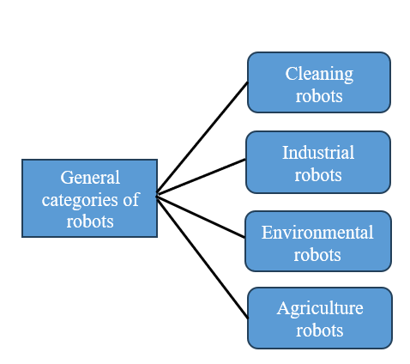

**Fig 1: General Categories of Robot**

Cleaning robots: A cleaning robot is a type of autonomous machine that is designed to clean with little or no human during the task. Operating based on the sophisticated, advanced technologies (such as sensors and artificial intelligence), the robot navigates throughout your various environments to perform general tasks such as vacuuming, scrubbing, or even sanitizing. These robots can use different methods like simultaneous localization and mapping (SLAM) to make maps of spaces, avoid situations objects during movement and get the most efficient cleaning route [5]. This robot scope is so wide that some are floor specific while other is window, pool or water body specific too. They are designed to be more efficient in the cleaning process, reduce human labor and function continuously; therefore, they are adaptable over a variety of surfaces or types of dirt. They clean the street using special tools like brushes or UV light to create a design.They are designed using specialized tools, such as brushes or UV light, for unique cleaning requirements in complex settings such as underwater or industrial environments. This is especially useful in maintaining hygiene standards in public spaces, industries, and environments where human cleaning is difficult or hazardous.[3]Just as floor-cleaning robots can switch between vacuuming and mopping, water-cleaning robots might have modules for surface skimming (collecting floating waste) and deeper water filtration. Many water robots are solar-powered for extended operation times, which is both eco-friendly and practical, as they can recharge during daylight hours.

Industrial robots: The industrial robots are being utilized for manufacturing aspects. Industrial robots are however automated and programmable Industrial robots are multifunctional machines in modern manufacturing that facilitate functions such as material handling, welding, and precision work at high speeds. Industrial robots come in various types; each one designed for different purposes. For example, articulated robots have a resemblance to the human arm and their flexible range of motion makes them ideal when it comes to welding and assembly. Cartesian robots operate along linear axes, making them appropriate for applications including 3D printing. They can either save people from having to do repeating or dangerous tasks, which means rapidly reducing human effort and bringing evenness. The evolution of technology like artificial intelligence (AI) and machine learning has made industrial robots smarter, more flexible, and a little less intimidating to work alongside. In all, industrial robots have raised the bar for different industries by maximizing manufacturing opportunities and thus opening a door towards more interconnected and streamlined production systems.

**Environmental Robots:**

Environmental robots are very much at the forefront in the drive towards sustainability, with their focus mainly on conservation and resource management. One of the most important ways they have been used involves water-cleaning robots, which clean waste products, pollutants, and invasive species from many water bodies. This category of robot operates both at the surface and below the water and is designed to use sensors and collection mechanisms that capture debris, even down to microplastic levels. Robots also play an important role in managing waste-particularly in sorting and recycling materials to reduce landfills.

In addition, air- and soil-quality-sensor-equipped robots can monitor pollutants, chemical levels, and other harmful substances in the air and soil environment. These monitor the changes in the parameter conditions, such as those from the levels of CO₂ and pH levels of the soil, for early detection of sources of pollution. Another important sector is biodiversity monitoring, where autonomous drones and ground robots monitor wildlife and plant species, habitat conditions, and so on. Such data gives credence to nature conservation, as scientists can study, among other things, migration patterns, biodiversity, and environmental health.

**Limitations of the Autonomous Surface Water Cleaning Robots Paper**

The paper on Autonomous Surface Water Cleaning Robots presents an innovative solution to water pollution, but it also has certain limitations that should be acknowledged:

Technological Dependence: The robot relies heavily on advanced sensor fusion and computer vision technologies for this navigation and waste identification. This could limit its performance in poor visibility or extreme weather conditions, thereby hindering the operational capabilities.

Cost of Implementation: The cost of implementation is high, and though the design emphasizes sustainability, the initial costs of developing and deploying such advanced robotic systems may be high.

Maintenance Requirements: Autonomous robots

require regular maintenance for proper functionality, which necessitates technical expertise that may pose limitations when utilized in remote locations.

Limited Waste Types: Although the robot is designed to distinguish between different types of waste, it might not be able to handle all types of debris, especially heavy or submerged debris. This might limit its ability to clean various water bodies with different types of pollution.

Scalability Issues: The paper discusses that the robot covers large areas. However, a big operations scale for cleaning extended water bodies will pose logistical issues. Coordinating multiple robots and ensuring them to work with efficiency may raise deployment complications.

In summary, while the paper presents a very promising solution for water pollution, it is absolutely necessary to point out these limits so that these challenges can be understood when one tries to translate this concept to practical autonomous robots for cleaning the water.

How the Robot Identifies Different Pollutants [5]:

The self-sustaining water cleaning robot utilizes various modern technologies to identify different types of pollutants in water bodies. The main methods that the robot employs are: Sensor Fusion: The robot is equipped with multiple sensors that work together to gather comprehensive data about the environment. Sensor fusion allows the robot to combine information from various sources, such as cameras and environmental sensors, to create a detailed understanding of its surroundings. This capability is crucial for accurately identifying different types of waste and pollutants present on the water surface.

Computer Vision Technologies: This robot uses computer vision to examine visual data it captures through cameras. The use of computer vision allows the robot to identify and categorize plastics, biomedical wastes, and other debris. Images are processed by the robot as it identifies the patterns to classify different pollutants accurately.

Machine Learning Algorithms: Although the paper does not provide explicit detail about the application of machine learning algorithms, most autonomous robots employ machine learning algorithms in classification applications. The robot could be trained with a labeled image dataset containing images of different types of pollutant so that, when in operation, it could learn to classify and distinguish among them.

Real-time Data Processing:

The robot structure should contain facilities for the real-time processing of all the sensor data coming to it onsite. This could enable instant in immidate identification of all the impurities that were detected during its operations followed by appropriate measures being taken to effectively handle those impurities. In short, the pollution types are identified through sensor fusion, computer vision technology, and probably machine learning algorithms. This, in turn, makes the robot independent, yet effective at cleaning water surfaces to specific types of waste [3].

Contributions of the Paper on Autonomous Surface Water Cleaning Robots

This paper makes various key contributions to the field of environmental management and robotics. Especially in the war against water pollution. The contributions are as follows:

Integration of Advanced Technologies: It uses sensor fusion, computer vision technologies to male the robot operate in an autonomous mode and navigates through floating garbage and waste collecting wastes effectively [5].

Sustainability Focus: There has been focus on sustainability aspects through the employment of green products and energy consuming parts. From the perspective of renewable sources such as solar, the robot produces less carbon by aligning to global initiatives set up for this purpose of having sustainable activities reduce climate change influences.

Proactive Solution to Water Pollution: The autonomous water cleaning robot is, therefore, one proactive solution meant to curb the increasing water pollution caused by irresponsible waste disposal practices. Its potential to work twenty-four hours in a day with the coverage of large areas consisting of water bodies further contributes more to effective and efficient cleaning operations that fulfill this urgent need to improve waste management.

Future Works Suggested in the Paper

The paper outlines several potential future works that could enhance the capabilities and effectiveness of the autonomous water cleaning robot. Here are the key suggestions:

Improvement of Sensor Technologies: Future research could focus on enhancing the sensor technologies used in the robot. This may involve developing more advanced sensors that can detect a wider range of pollutants, including microplastics and chemical contaminants, thereby improving the robot's cleaning efficiency and effectiveness in diverse environments.

Integration of Artificial Intelligence: The incorporation of more sophisticated artificial intelligence (AI) algorithms could be explored. This would enable the robot to learn from its experiences and improve its decision-making processes over time, allowing for better navigation and waste identification in complex water bodies.

Collaboration with Other Technologies: The paper suggests exploring the potential for collaboration with other technologies, such as drones or stationary monitoring systems. This could create a more comprehensive approach to water pollution management, where different systems work together to monitor and clean water bodies more effectively.

Field Testing and Real-World Applications: Conducting extensive field tests in various aquatic environments would be essential for validating the robot's performance. Future works could focus on deploying the robot in real-world scenarios to gather data on its effectiveness and make necessary adjustments based on practical observations.

Problem Statements for Cleaning Robots:

Environmental and Safety Challenges:

In high-risk environments like power lines, human workers face dangers such as high altitudes and exposure to voltage. Cleaning and maintenance robots address these risks by performing tasks traditionally done by humans, reducing the need for direct human interaction​.

Efficiency and Flexibility: Current medical delivery robots face the challenge of needing adaptable features to meet varied demands (e.g., temperature-sensitive organ transport or aseptic drug delivery). The modular design of these robots allows for flexible configurations to suit different hospital needs​.

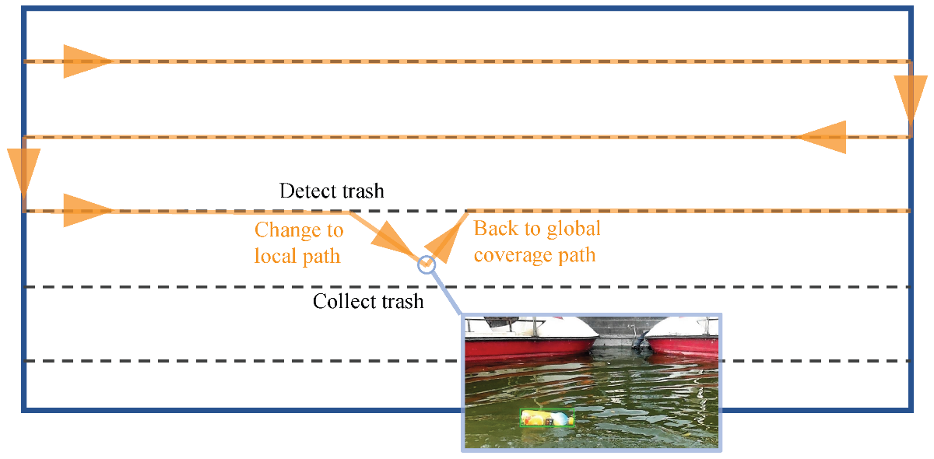

**Fig: 2 Autonomous Navigation and Control System Architecture for Water Cleaning Robot.**

In water cleaning operations, energy conservation is critical due to limited battery or solar reserves. Figure 2 highlights a practical approach to minimize unnecessary movements. Robots follow energy-efficient global paths and activate local processing units only when waste is detected. This behavior is typically controlled using lightweight AI models like TinyYOLO or MobileNet, capable of real-time inference on edge devices with minimal power draw.

By maintaining the robot in passive mode during non-critical operations and activating full systems only during collection phases, energy usage is drastically reduced, allowing longer operation times, particularly for solar- or wave-powered robots.

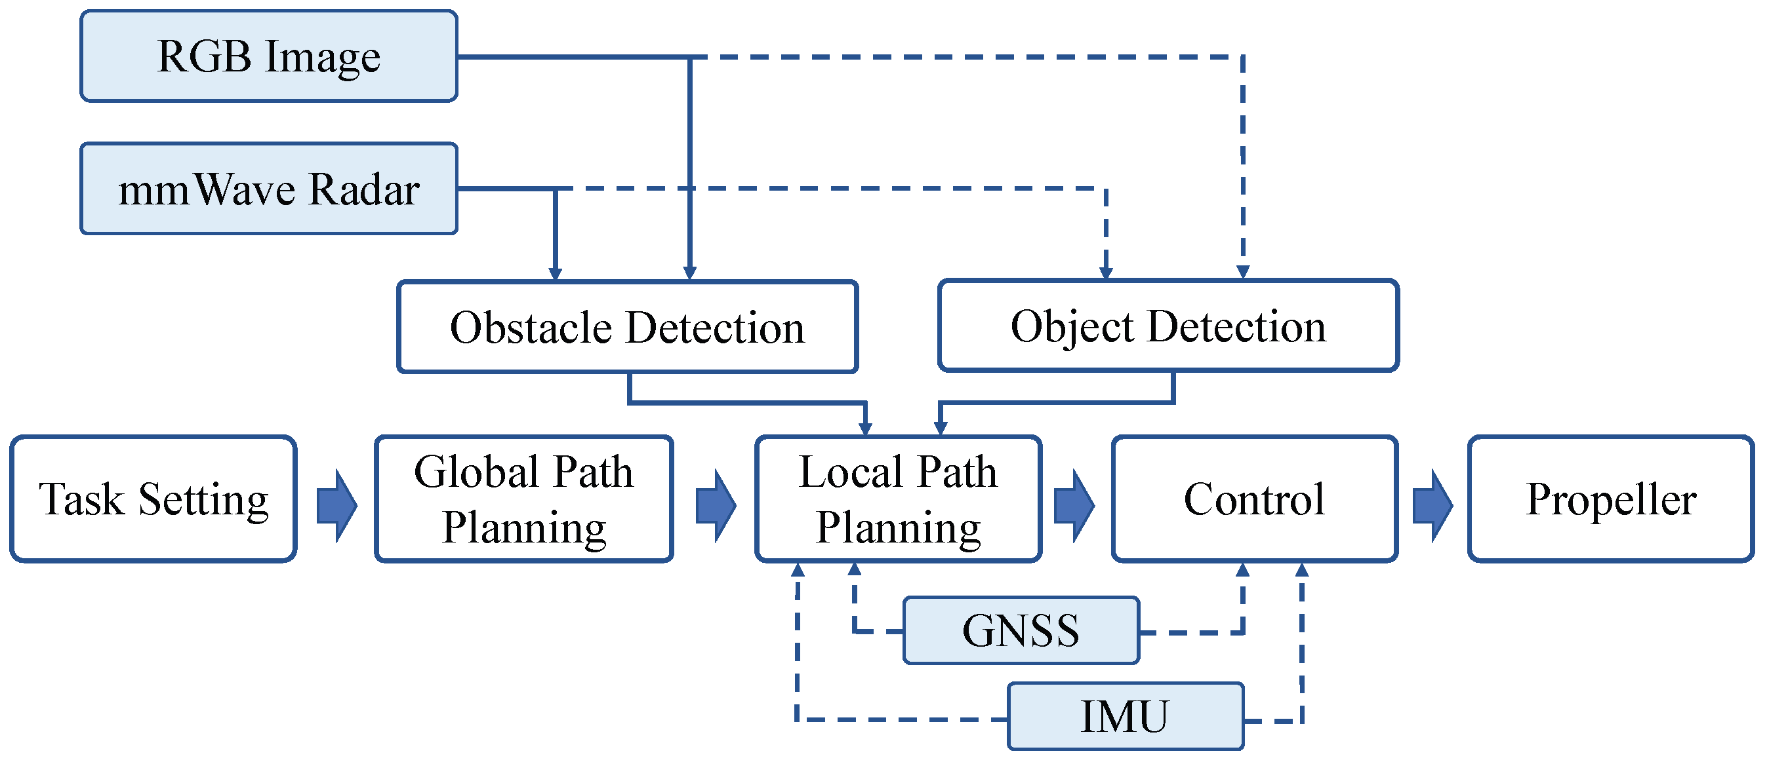

**Fig: 3 Adaptive Trash Detection and Path Switching in Real-Time.**

|  |  |  |  |
| --- | --- | --- | --- |
| **TABLE I: LIST OF VARIOUS METHODOLOGIES AND APPLICATIONS OF ROBOT** | | | |
| **Paper title** | **Methodology** | **Where they tested it** | **Applications** |
| Role of trust in customer attitude and behavior formation towards social service robots [9]. | The study analyzes how trust in AI and social service robots influences customer attitudes and behavior using quantitative surveys and statistical modeling. | The research was conducted in hospitality settings like hotels and airports to assess customer interactions with service robots. | The findings help improve customer acceptance of service robots, optimize robot design for hospitality, and guide businesses in enhancing AI-driven services. |
| In-water surface cleaning robot: Concept, locomotion, and stability [6]. | The paper introduces a flexible crawling mechanism using suction cups and water jets for stable adhesion and cleaning of underwater surfaces. | The robot was evaluated for stability and locomotion on different underwater surfaces, including ship hulls and industrial installations. | It is used for underwater cleaning, bio-fouling removal, and maintenance of submerged structures like ships and power plants. |
| Modeling and Experiments of Rotary Percussive Drilling for Robotic Civil Infrastructure Rehabilitation [8]. | The study develops a mathematical model for rotary percussive drilling, incorporating dry friction and nonlinear elements to optimize robotic drilling performance for civil infrastructure repair. | The system was tested on bridge decks and concrete structures, using an in-situ force measurement system to validate drilling performance. | The robotic drilling system is used for automated infrastructure repair, specifically for bridge decks, tunnels, and civil engineering structures requiring non-destructive rehabilitation. |
| Robotics: Enabler and inhibitor of the Sustainable Development Goals [4]. | The study uses a consensus-based expert elicitation process to assess how robotics enables or inhibits achieving UN Sustainable Development Goals (SDGs) by analyzing scientific literature and expert insights. | The study reviews robotics applications worldwide, covering economic, societal, and environmental impacts across multiple industries. | Robotics contributes to sustainable industry, environmental monitoring, automation, and economic growth but may also exacerbate inequalities and ethical concerns in some cases. |
| An improved single short detection method for smart vision-based water garbage cleaning robot [2]. | The robot uses an improved SSD-based vision system with ResNet-50 for accurate waste detection and collection. | The system was tested on various water bodies, including lakes, coastal areas, and inland streams.​ | The robot is used for autonomous water cleaning, garbage collection, and environmental monitoring. |
| Approaching Robotics and Autonomous Systems as an Integrated Materials, Energy, and Control Problem [1]. | The approach integrates materials science, energy management, and control to create dynamic robotic systems, with interdisciplinary collaboration in design, fabrication, and testing​. | Includes laboratory-based testing, as well as applications across industrial, defense, and research settings, often specific to the environment being simulated | Autonomous systems for industrial tasks, healthcare, defense, agriculture, and exploration, focusing on adaptability and energy efficiency in varied environments |
| SMURF: A Fully Autonomous Water Surface Cleaning Robot with A Novel Coverage Path Planning Method [3]. | The paper introduces a fully autonomous water surface cleaning robot named SMURF. It uses a novel Coverage Path Planning (CPP) method that adapts to irregular boundaries and obstacles, along with an improved nonlinear model predictive controller (NMPC) for precise path tracking. The system integrates sensors, including RGB cameras and mmWave radar, to perceive the environment and optimize cleaning operations. | SMURF was tested in real-world environments, including inland waterways, lakes, and coastal areas, under various weather conditions. | SMURF is designed for cleaning floating debris in various water bodies, including inland waterways, lakes, coastal areas, and marinas. It aims to replace dangerous and inefficient manual operations for water surface cleaning. |
| Design of a new composite underwater hull cleaning robot [5]. | The robot integrates mechanical cleaning with cavitation jet cleaning. The design includes a rolling brush module for initial cleaning and a cavitation jet module for deeper, non-destructive cleaning. Testing involved structural simulations using SolidWorks and fluid simulations with Fluent. | Testing and simulations were conducted virtually to assess structural integrity and fluid dynamics | Primarily for ship hull cleaning in various marine environments, especially useful in ports, docks, and shipyards. The robot’s technology helps reduce marine fouling, improving fuel efficiency and reducing corrosion. |
| A Water Surface Cleaning Robot[7] | This robot, designed for collecting floating debris, has a pontoon-shaped hull for stability and a motor-driven arm for waste collection. Controlled remotely using an XBee-based system, it can maneuver in tight spaces and is equipped with a differential drive for easy movement. | Tested in a controlled water area to confirm stability, functionality, and load capacity. | Effective for clearing debris in water bodies, helping prevent clogging and flooding. Potential future uses include monitoring water quality and removing algae. |

**Results**

The look at those self-cleaning water robots shows some serious progress in how they're built, how smart they are, and how they're all about keeping things green and clean. The study's findings are well-supported by the data.Robots like SMURF and those using ResNet-50 and SSD models nailed it when it came to spotting and sorting out floating trash like plastic, leaves, and algae. These robots were pretty good at using color cameras and smart computer programs to figure stuff out in real places like city lakes and beach areas.Most systems were built to be power saving, using solar energy and lightweight AI models like MobileNet or TinyYOLO. This means the robots can handle data on the fly without guzzling too much power, so they're great for tasks that go on for a while. Using a mix of RGB cameras, sensors that check the environment, and mmWave radar, the robots got better at spotting trash and could handle different lighting or visibility situations.Robots use smart techniques like Coverage Path Planning and Nonlinear model, they use Predictive Control to navigate around stuff without bumping into things and make the cleaning path as efficient as possible.Robots got put to the test in all sorts of water places like rivers, lakes, shipyards, and coastal areas.

**Discussion:**

The implications lead towards the potential contribution of independent water cleaning robots towards mitigating increasing instances of water pollution. While remarkable in their work towards collecting surface wastage, there are some other numerous significant factors that should also be given due attention:Limitations of Technology: The robots, so effective at detecting and picking up floating litter, remain short of detecting and capturing submerged and dissolved pollutants. Use of image-based models restricts their power to deal with subsurface pollution. Limitations of the Environment: Real-time detection apparatuses fail in extreme environments like low illumination, polluted water, or high turbidity, compromising camera and sensor accuracy. Scalability and Coordination Challenges: Numerous robots would need to be deployed at once to effectively cover lengths of water efficiently. It is a tricky problem coordinating their route of navigation and communication among units. Real-World Test Requirement: In spite of the fact that most systems were tested under controlled or semi-controlled conditions, long-term operation in real-world environments with uncertainty, high contamination, or high biological richness must still be demonstrated convincingly. Integration with Larger Systems: Next-generation projects can be enabled by integrating water-cleaning robots with stationary sensor stations, drones, or satellite systems for cross-scales environmental sensing and response. In brief, although existing autonomous water-cleaning robots represent a milestone in environmental robotics, practical use at scale requires refinement in adaptability, affordability, and inter-system cooperation.

**Conclusion:**

The increasing prevalence of water pollution due to industrial discharges, plastic waste, oil spills, and agricultural runoff has led to severe consequences for ecosystems, human health, and economies. These adverse effects underscore an urgent need for innovative solutions that reduce human risk and improve cleaning efficiency in water bodies. This study on autonomous robotic systems,

particularly water-cleaning robots, highlights a promising avenue for addressing these challenges. Equipped with advanced sensors, artificial intelligence, and navigation systems, these robots can autonomously clean lakes, rivers, coastal areas, and other water bodies. Their ability to operate without human intervention allows them to reach hazardous areas and handle difficult cleaning tasks that are otherwise inefficient or dangerous for humans.

Advanced technology and human ingenuity are required to control water pollution. System for example, the SMURF robot collected debris efficiently with the help of CPP, RGB cameras and mmWave radar. Human inspection has never gone out of the window with all these innovations.

Durability, navigation accuracy, and complex water conditions call for collaboration in engineering, scientific, and community efforts. Sustainable practices are built into an integrated system by building efficiency in solar energy, hence reducing the

impact on the environment.

Future developments will include arming robots with water-quality sensors and fine-tuning navigation with human expertise. Involvement of human wisdom is at its best because technology cannot tackle all problems alone. Ideal solutions for cleaning water are proper balances between automation and human wisdom.  
In collaboration, engineers and scientists with communities can design scaling systems that keep water clean and biodiversity intact. Shared responsibility will ensure a sustainable future for ecosystems.

For water-cleaning robots to be as effective as possible, it is necessary to consider how and when they utilize energy. Much thought must go into developing operating systems for water-cleaning robots that prioritize long-term environmental sustainability - this might be especially true if we are talking about a robot in a remote area or large body of water. Strategies like installing solar panels, building with lightweight materials, employing energy-efficient electronics, keeping the robot in one area - these measures will help lessen the burden on the battery system and human staff. Some designs are so advanced that they attempt to harvest naturally occurring energy, harvesting wave and solar energy for self-recharging and extended hours of output.

Beyond energy aware implementations, intelligent decision-making is another important dimension to robot performance that has been promising to address. With onboard processing, the robot can better and quicker pick-up waste and better plan its direction. For example, upon spotting an item of debris, the robot can adjust its path in real-time, thus becoming more efficient with the time and energy it consumes. It will also continue evaluate "successful" and "unsuccessful" patterns to react even better to the changing surroundings.

The combination of energy aware systems and intelligent route-driving systems will produce strong operational tensions for a robotic cleaning program that–instead of needing to be constantly teleoperated or follow robotic patterns – are positioned better position to clean.

**REFERENCES:**

1. Walsh, S. M., Strano, M. S., & Stanton, S. C. (2019). Approaching robotics and autonomous systems as an integrated materials, energy, and control problem. *Robotic systems and autonomous platforms: Advances in materials and manufacturing*, 19-46.
2. Haldorai, A., Suriya, M., & Balakrishnan, M. (2024). An improved single short detection method for smart vision-based water garbage cleaning robot. *Cognitive Robotics*, *4*, 19-29.
3. Zhu, J., Yang, Y., & Cheng, Y. (2022). SMURF: A fully autonomous water surface cleaning robot with a novel coverage path planning method. *Journal of Marine Science and Engineering*, *10*(11), 1620.
4. Haidegger, T., Mai, V., Mörch, C. M., Boesl, D. O., Jacobs, A., Khamis, A., ... & Vanderborght, B. (2023). Robotics: Enabler and inhibitor of the sustainable development goals. *Sustainable Production and Consumption*, *43*, 422-434.
5. Rahmawati, E., Sucahyo, I., Asnawi, A., Faris, M., Taqwim, M. A., & Mahendra, D. (2019, December). A water surface cleaning robot. In *Journal of Physics: Conference Series* (Vol. 1417, No. 1, p. 012006). IOP Publishing.
6. Albitar, H., Ananiev, A., & Kalaykov, I. (2014). In-water surface cleaning robot: concept, locomotion and stability. *International Journal of Mechatronics and Automation*, *4*(2), 104-115.
7. Roy, S. K., Singh, G., Sadeque, S., & Gruner, R. L. (2024). Customer experience quality with social robots: Does trust matter? *Technological Forecasting and Social Change*, *198*, 123032.
8. Guo, C., & Yi, J. (2017). Modeling and experiments of rotary percussive drilling for robotic civil infrastructurerehabilitation. *IFAC-PapersOnLine*, *50*(1), 9784-9789.
9. Della Corte, V., Sepe, F., Gursoy, D., & Prisco, A. (2023). Role of trust in customer attitude and behaviour formation towards social service robots. *International Journal of Hospitality Management*, *114*, 103587.

[10]. Jassal, R. (2024). Sanitation Work is an Occupation or A Caste Identity in India?.

[11]. Chang, H. C., Hsu, Y. L., Hung, S. S., Ou, G. R., Wu, J. R., & Hsu, C. (2021). Autonomous water quality monitoring and water surface cleaning for unmanned surface vehicle. *Sensors*, *21*(4), 1102.

[12]. A.H. Elsheikh, T. Muthuramalingam, S. Shanmugan, A.M. Mahmoud Ibrahim, B. Ramesh, A.B. Khoshaim, E.B. Moustafa, B. Bedairi, H. Panchal, R. Sathyamurthy, [Fine-tuned artificial intelligence model using pigeon optimizer for prediction of residual stresses during turning of Inconel 718](https://www.sciencedirect.com/science/article/pii/S2238785421011078), Journal of Materials Research and Technology, Elsevier, 15, (2021), 3622-3634, <https://doi.org/10.1016/j.jmrt.2021.09.119>, IF – 6.2 Q1 76.

[13]. A. Sangeetha, S. Shanmugan, Shiva Gorjian. Experimental evaluation and thermodynamic Gibbs free energy analysis of a double-slope U-shaped stepped basin solar still using activated carbon with ZnO nanoparticles [Journal of Cleaner Production](https://www.sciencedirect.com/journal/journal-of-cleaner-production). [Volume 380, Part 2](https://www.sciencedirect.com/journal/journal-of-cleaner-production/vol/380/part/P2), 20 December-2022,135118.-DOI <https://doi.org/10.1016/j.jclepro.2022.135118>

[14]. AS Abdullah, Wissam H Alawee, S Shanmugan, ZM Omara, Techniques used to maintain minimum water depth of solar stills for water desalination–A comparative review. Results in Engineering Volume 19, 101301,September-2023,101301 <https://doi.org/10.1016/j.rineng.2023.101301>

[15]. Dharani Kolli, Sonali Biswas, A Venkateswara Rao, Sayed M Saleh, S Shanmugan. Modulating ZnO nanoparticle photoluminescence through Ce³⁺-Induced defect engineering: A study of microstructural and spectroscopic properties. Ceramics International Volume 51, Issue 7, March 2025, Pages 8472-8479. <https://doi.org/10.1016/j.ceramint.2024.12.278>

[16]. AS El-Shafay, Ümit Ağbulut, S Shanmugan, MS Gad. Production of oxy-hydrogen with an alkaline electrolyzer, and its impacts on engine behaviors fuelled with diesel/waste fish biodiesel mixtures supported by graphene nanoparticles. Energy Volume 314, 1 January 2025,133934. <https://doi.org/10.1016/j.energy.2024.133934>.

[17]. Durga Prasad Kotla, Venkateswara Rao Anna, Seepana Praveenkumar, Sayed M Saleh, S Shanmugan. Optimizing solar still performance: A study of TiO2 nanofluid derived from Saccharum officinarum L. Separation and Purification Technology Volume 359, Part 2, 22 June 2025, 130584. <https://doi.org/10.1016/j.seppur.2024.130584>